CURRICULUM VITAE

TAXELL, Lars Evald Christoffer
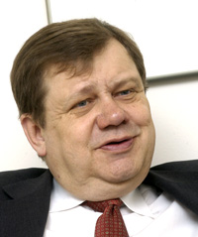

- Born February 14th, 1948 in Turku, Finland
- Master of Law, 1972 (University of Turku)
- married 1974 to Rachel Margareta Nygård(-Taxell), Master of Econ. and Business Administration
- Children: Johanna 1984, Sofia1988

* * *

- Assistant Lecturer at the Swedish School of Economics of Åbo Akademi University 1973-1975

- Member of Parliament 1975-1991
- Minister of Justice 1979-1987
- Minister of Education and Science 1987-1990
- Chairman of the Swedish People's Party, Finland 1985-1990

- Member of the Board of Partek Corporation 1984-2002
- President and Chief Executive Officer of Partek Corporation 1990-2002

- Chairman of the Board of the Confederation of Finnish Industries EK, 2005&2006

- Chairman of the Board of Finnair Plc since 2003
- Chairman of the Board of Stockmann Oyj Abp since 2007
- Member of the Board of Stockmann Oyj Abp since 1985
- Member of the Board of Sampo plc since 1998
- Member of the Board of Raisio plc since 2003
- Member of the Board of Nordkalk Corporation since 2003
- Member of the Board of Luvata Group (former Outokumpu Copper) since 2005

* * *

- Member of the Board of Åbo Akademi University Foundation since 1988, Chairman since 2003
- Dr. Pol. Sc. (h.c.), Åbo Akademi University 1998
- Chancellor of Åbo Akademi University since 2004

December 2007

